Name : Fung Cheuk Lai Student ID: 190026107  
Class/module: IT114107 1B

For this assignment scenario, I assume myself is the owner of a music club and wrote a 3 page web.   
  
In the first page, this will be the main outlook of the whole main page,  
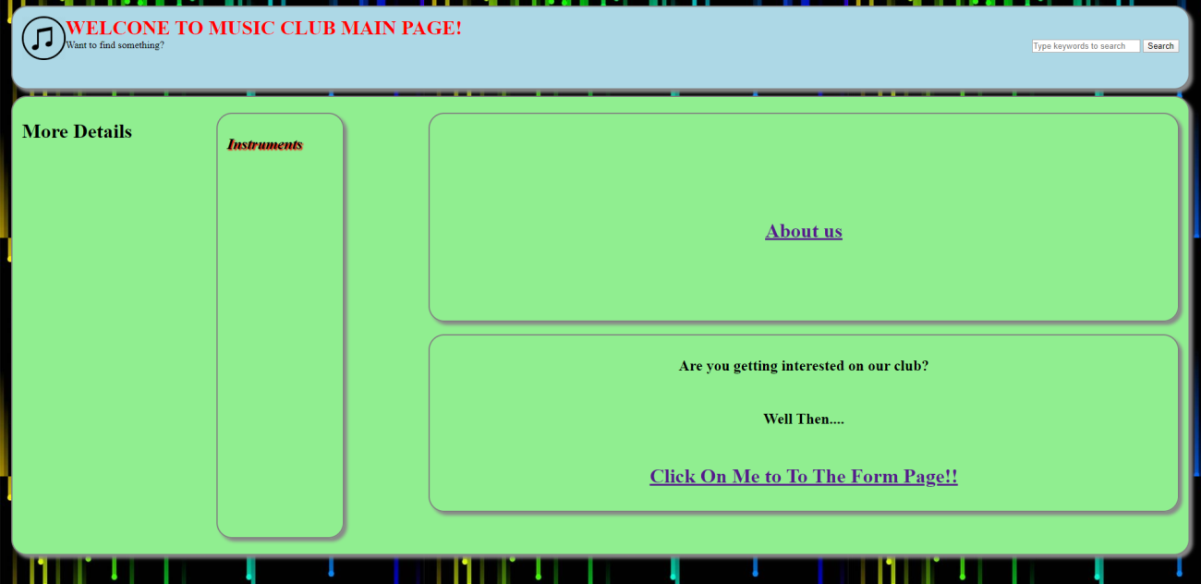

Firstly, I use style feature to set the background to “bg.png”.This also apply to all 3 page.  
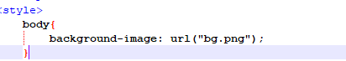

Second, I set up the div boxes width, height and their border, box shadow and also I set up the biggest div box displays as flex container, and make order to each of div boxes.

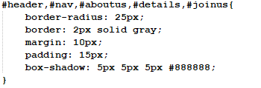

After these setting, I start to make some features in this page.

First, I make the icon  can be bigger when the user’s mouse in over it slowly in 3s,  
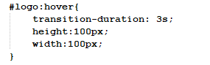

Second, I make a search box can direct user’s input to search it in google by script  


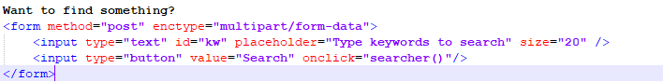

When user type what they want to search and press the search button

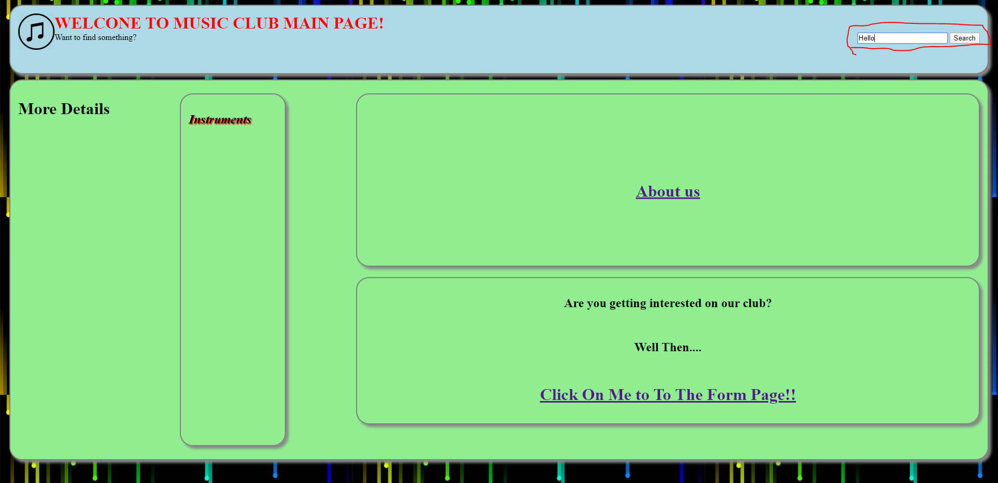

It will redirect the page to the google page that search for that keyword.  
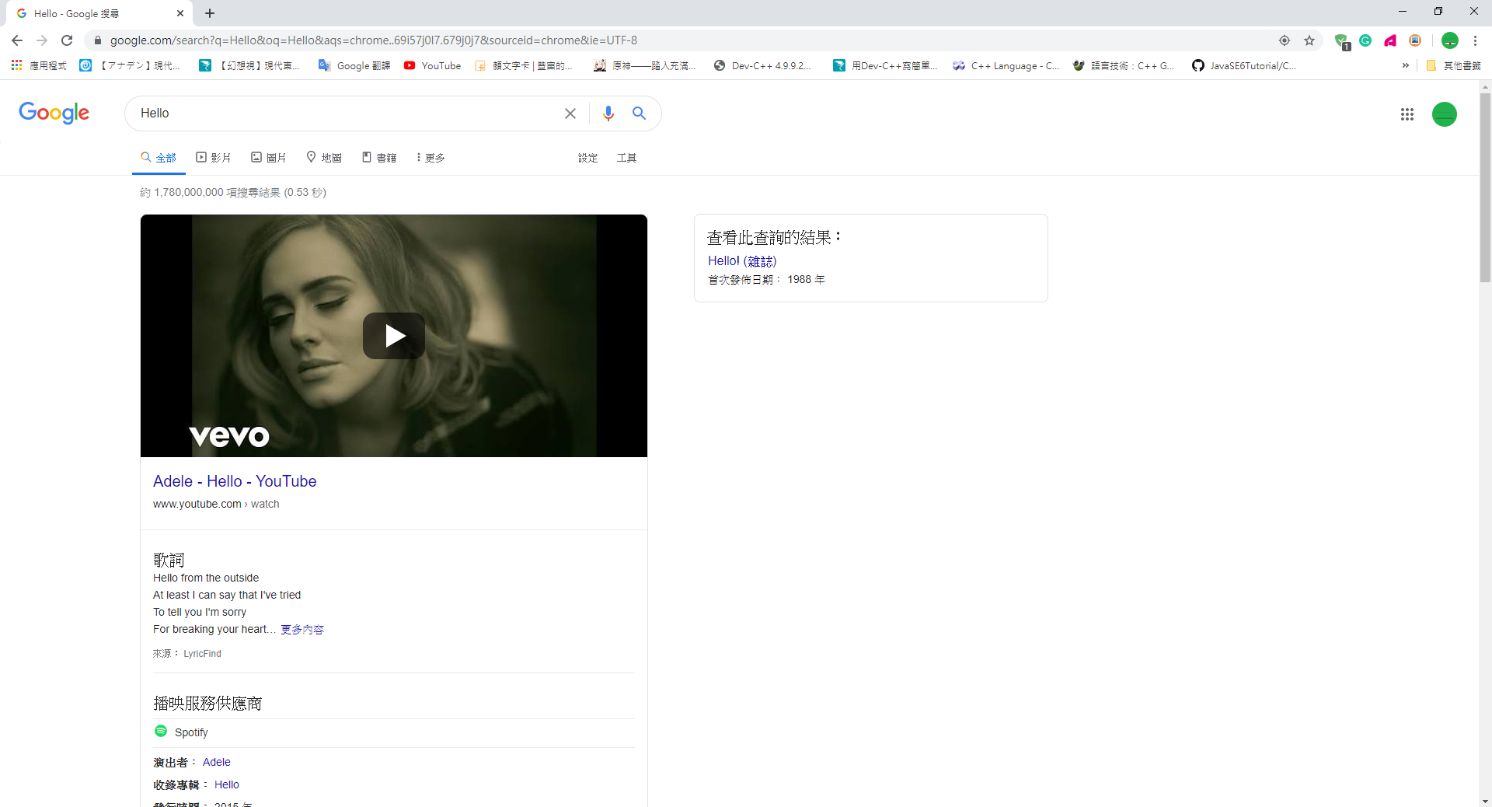

Third, I make a hidden menu , there a “Instrument” in that div box,  
when user mouse move over it, the 3 hidden subitem will appear

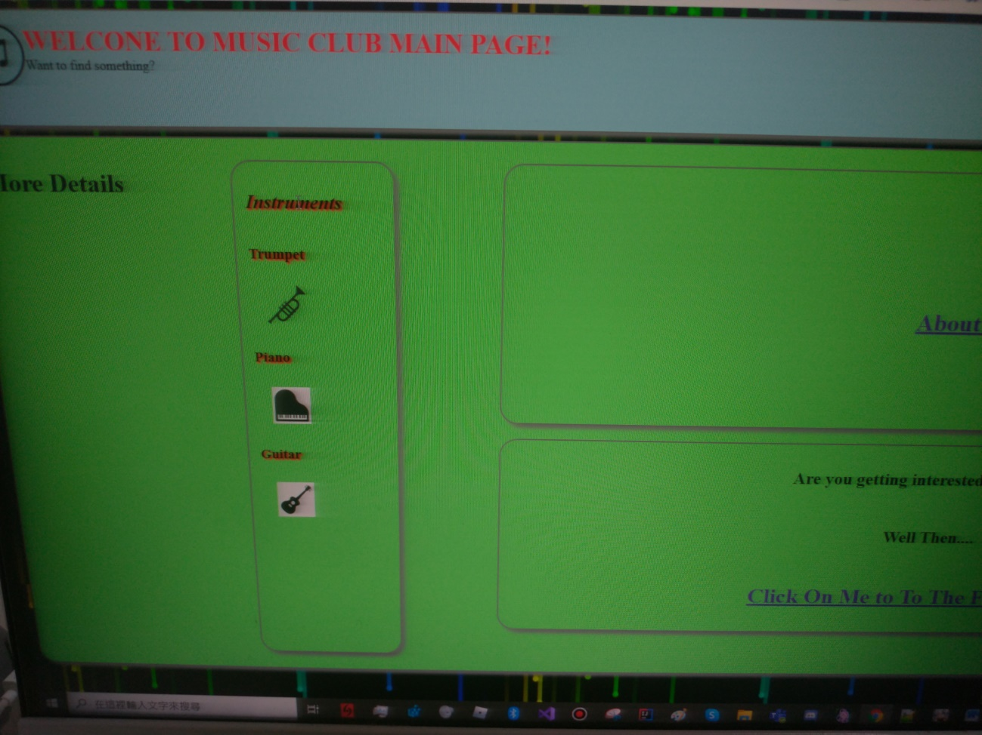  
They are 3 a href item with img src that can direct to Wikipedia page of Trumpet, Piano and Guitar.  
When user move the mouse on it and it will turn to blue.

For example, if user click on the trumpet icon, it will redirect the page to trumpet’s Wikipedia page,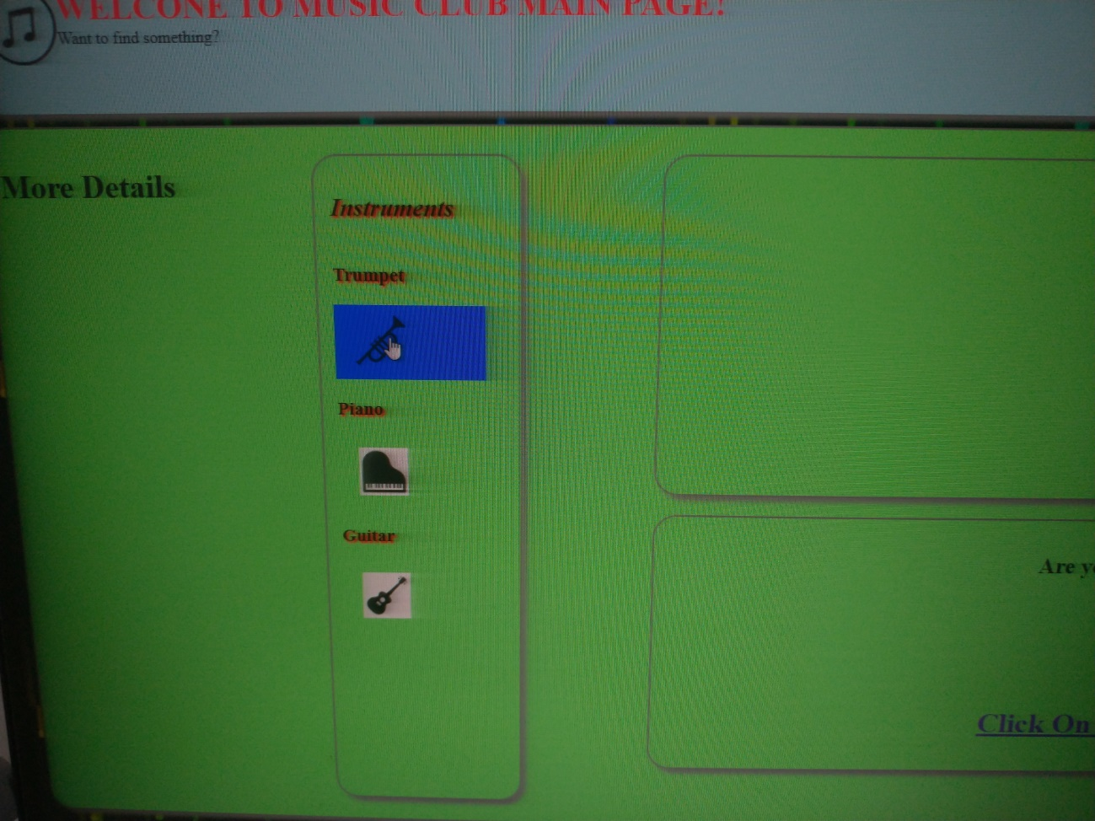  
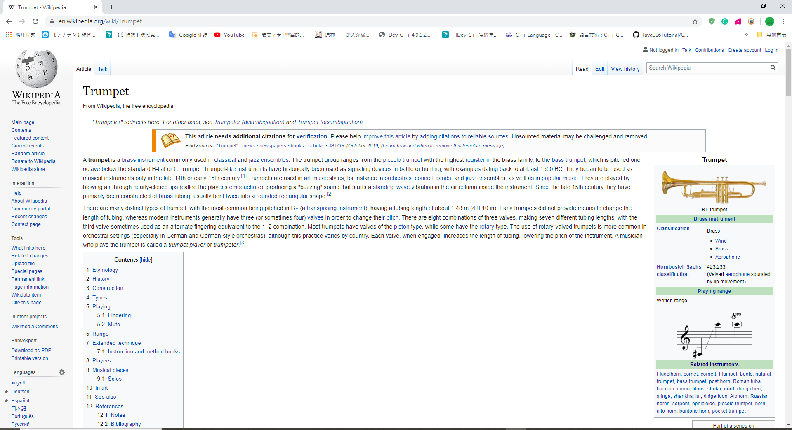

And this will be the css code that I wrote to do this

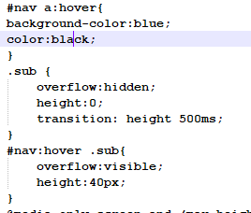

Fourthly, I makes all a href with text only (include in page2 and 3) can be red color when they got a mouse over,

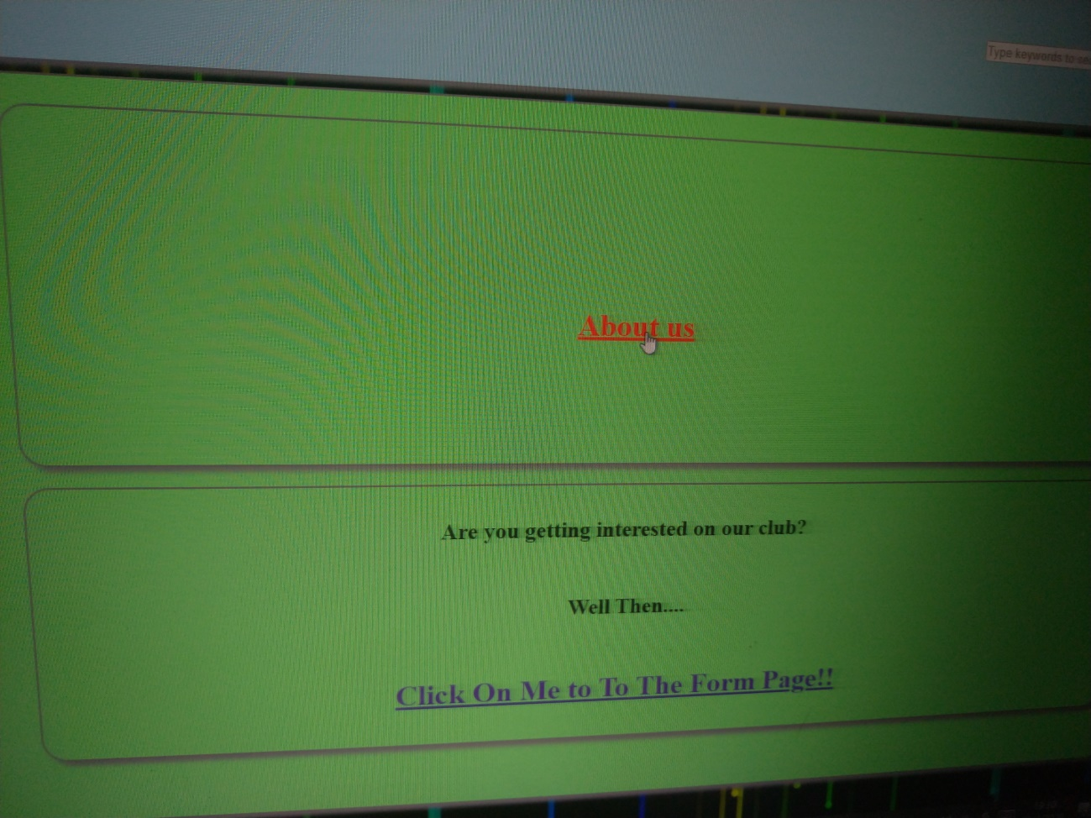

I do this with these css code to detect a’s hover and turn the color to red

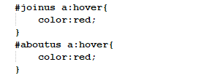

Finally, in this top page, when the page shrink to a height smaller than 750 px, then the order of div box that contain the a href link to form page and the hidden menu div box will exchange their position, such that to make the form link can be more easily to click on.

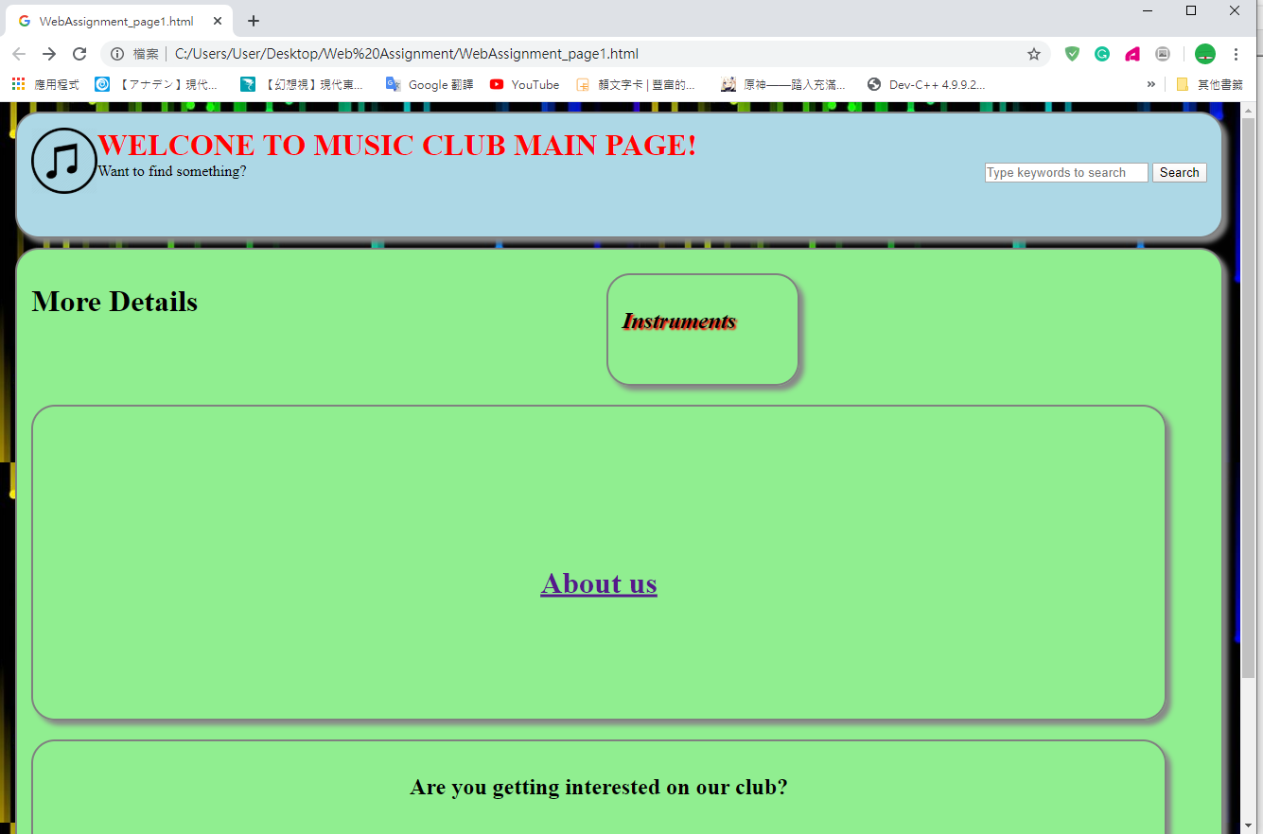

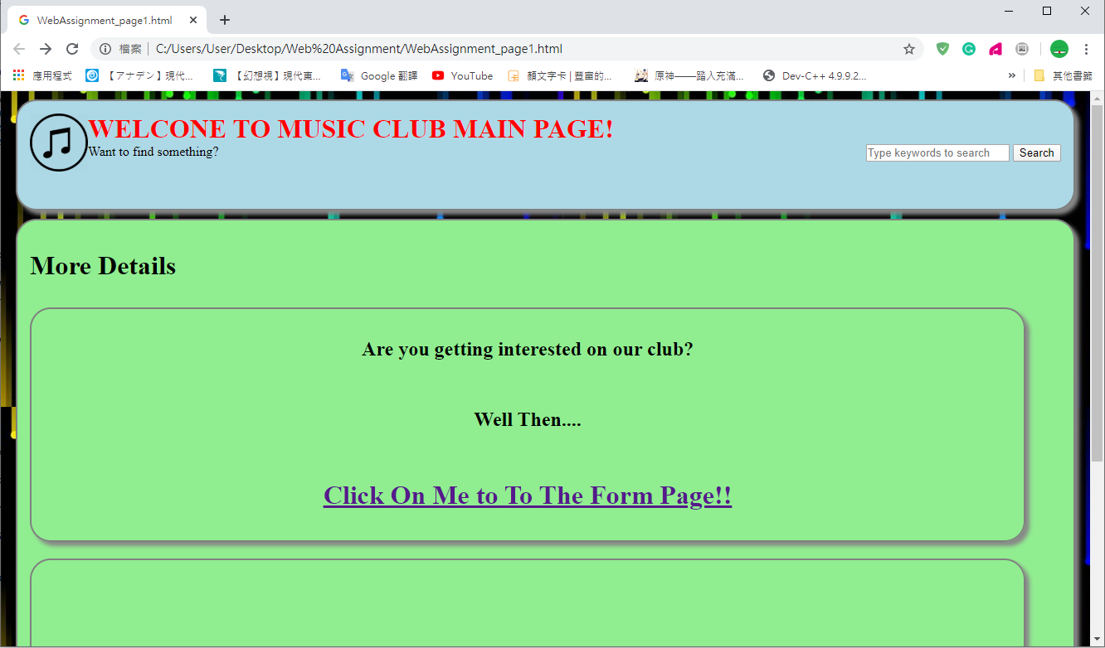

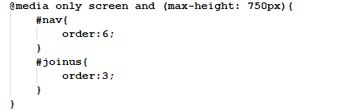

These are the features on top page.  
On the page2, user can click on the a href “About us” to redirect to it.  
This will be the information page of this club, which include big div box contain with small div box, and I also use the flex container display on the div box and order on boxes and it looks like this  
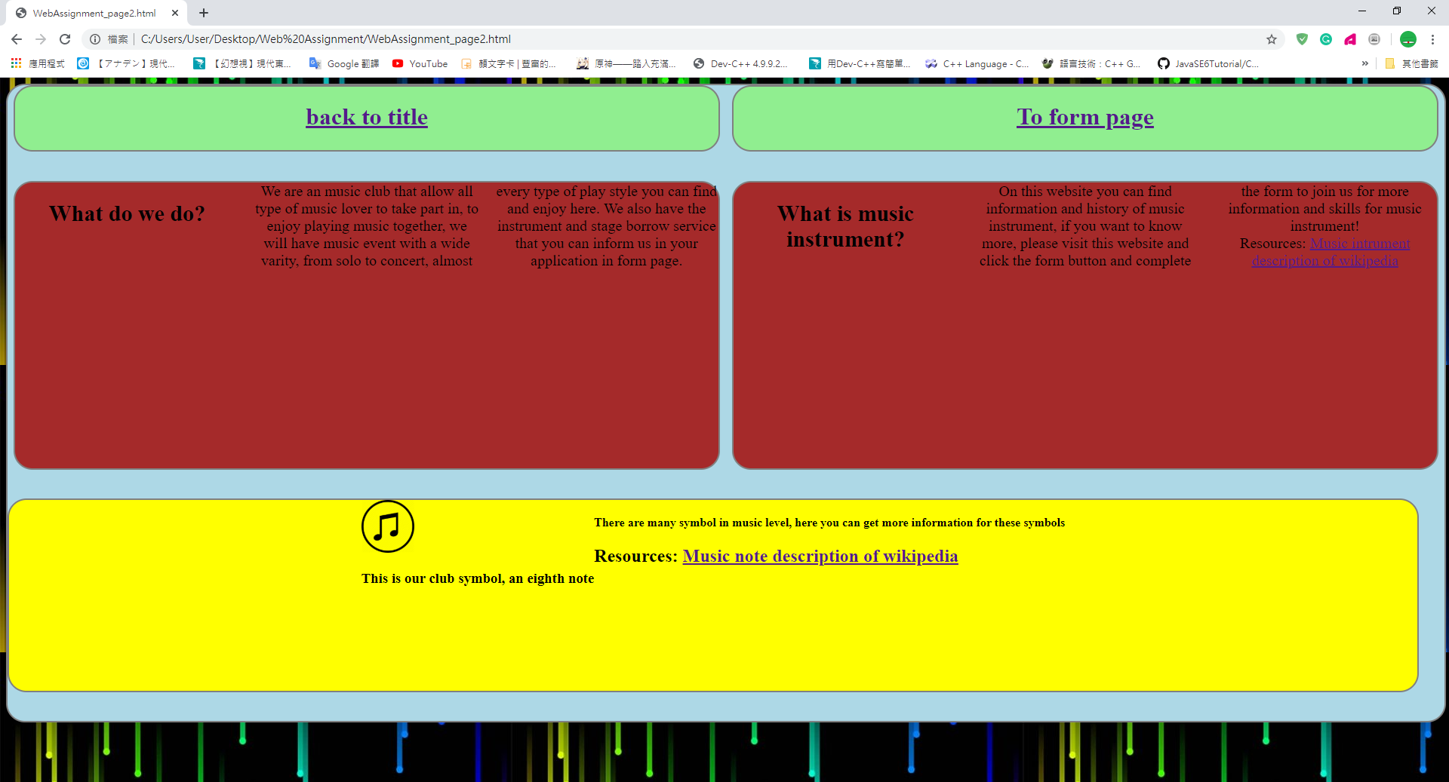

The background is same method and same picture with page 1, to make all pages look like well formed, on the top 2 lightgreen div boxes, contain same a href direct to the top page and page 3,

This is the css code I use to tide up that 2 boxes and make the a href can be in the middle of the box.  
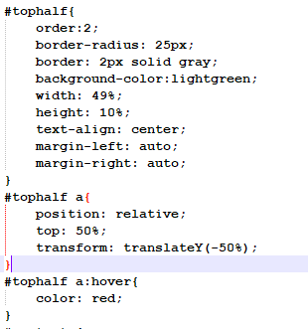

Second, about that 2 red div box, I make it display the text as 3 column and make the text be middle center of the box, make the size fixed with the biggest div box by these css code  
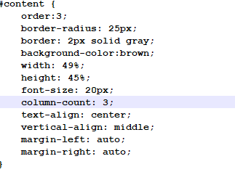

Furthermore, another feature of this page is that when the page’s width is smaller than 750px, the order of the 2 green div box and 2 red div box will exchange their position,  
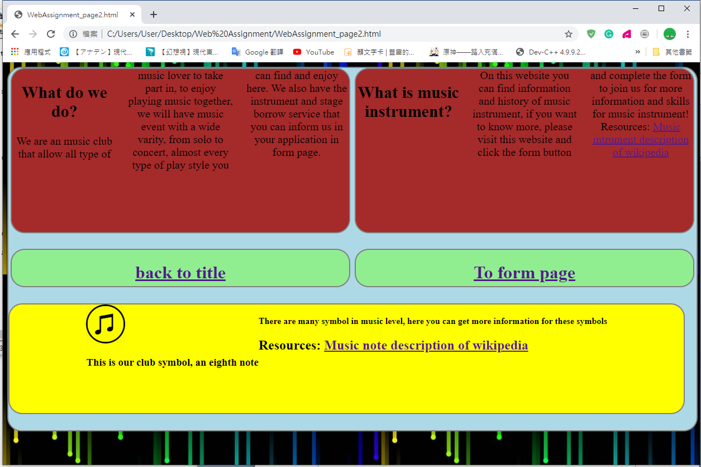

And if the height is smaller than 750 px, the display content of 2 red div box will be display as 2 column only, I did this by this 2 parts of css code.  
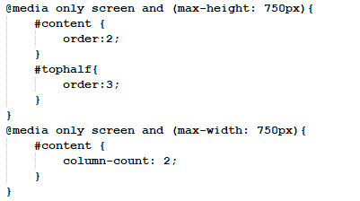

Finally, about the yellow box, I make the note logo can be bigger as the one in top page same as 3s and scale the box size by this area of css code.  
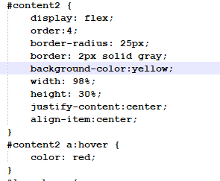

These are the features of Page2 (information page).

About Page3, it will be a Form page that can let the use to send out their application for membership of music club, in this scenario, I also make the club to have borrowing service that can let the user to have their payment in the page too. To begin with, user can direct to this page by pressing the a href link”To form page” in page2 or pressing the a href link “Click On Me to To The Form Page!!”. After the user pressed on of those, they will be direct to this page.  
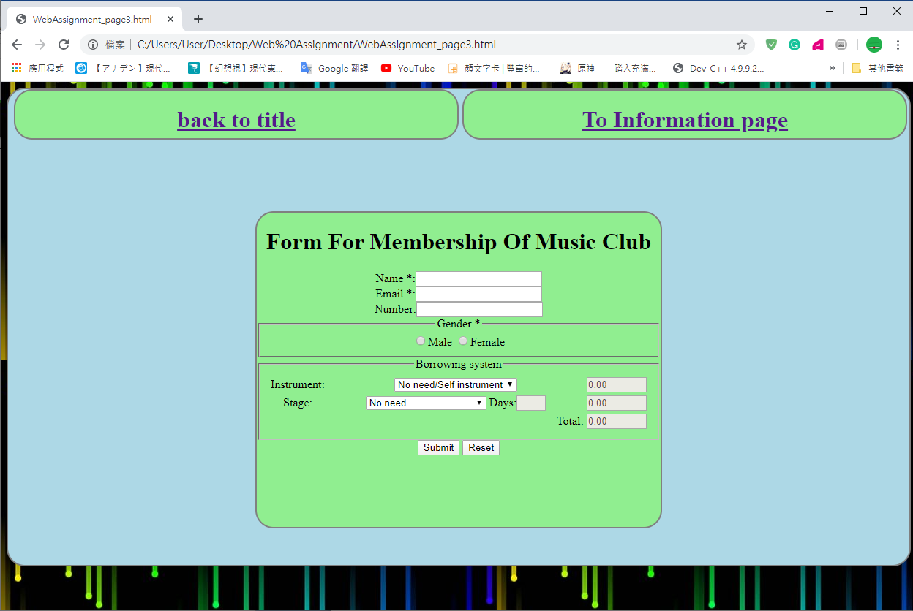

The two div box do the same function with the page2. “back to title” can direct to the top page, and the “To Information page” can direct to the page2.  
The main features of this page is on the form, mostly done by script of javascript.  
Firstly, I make those basic information be required but not for the number and the payment parts as not everybody have a phone or need to borrow something.  
I also set up format of the phone number, so the input can only start from 2-9 one digit and total length of 8 digit only. I did these checking by this part of code  


(not input name)

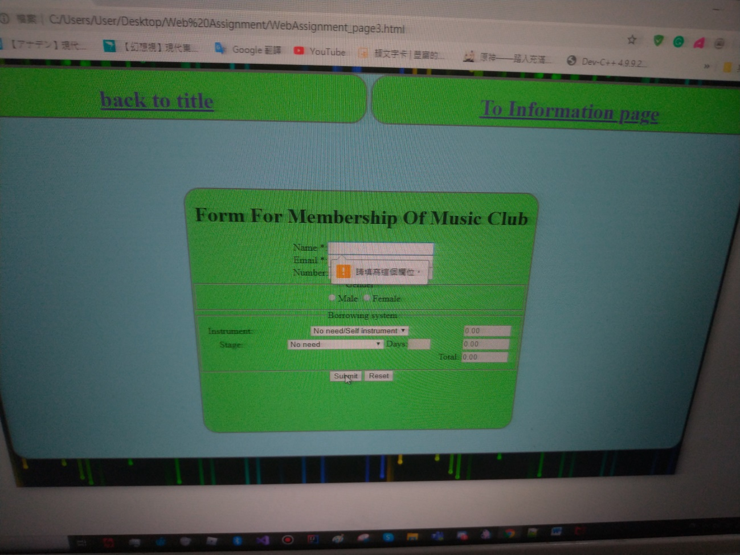

(Not input email)

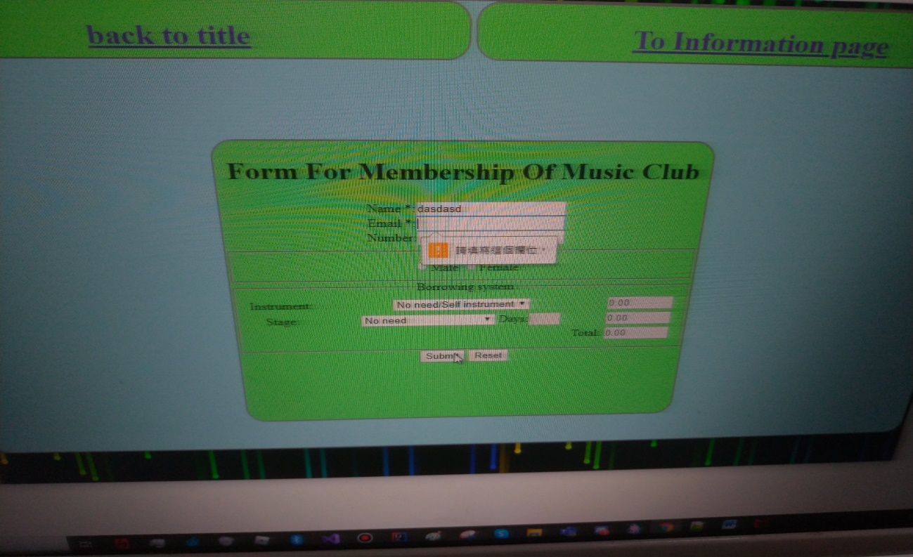

(input email in wrong format)

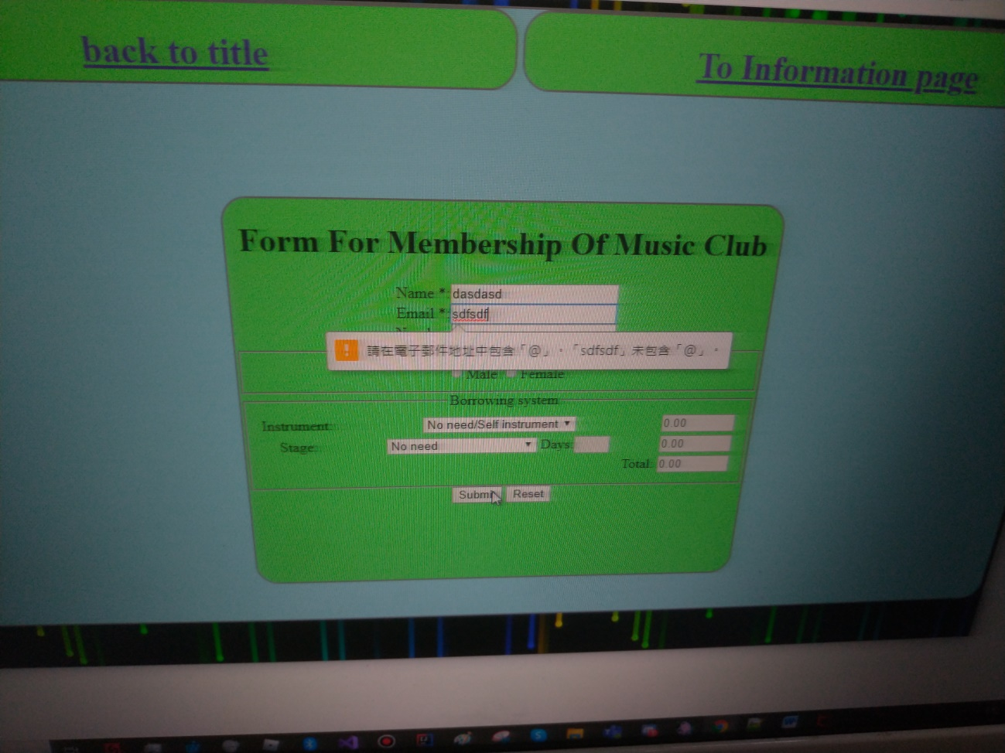

(not check on gender and show the free to blank the phone text input)

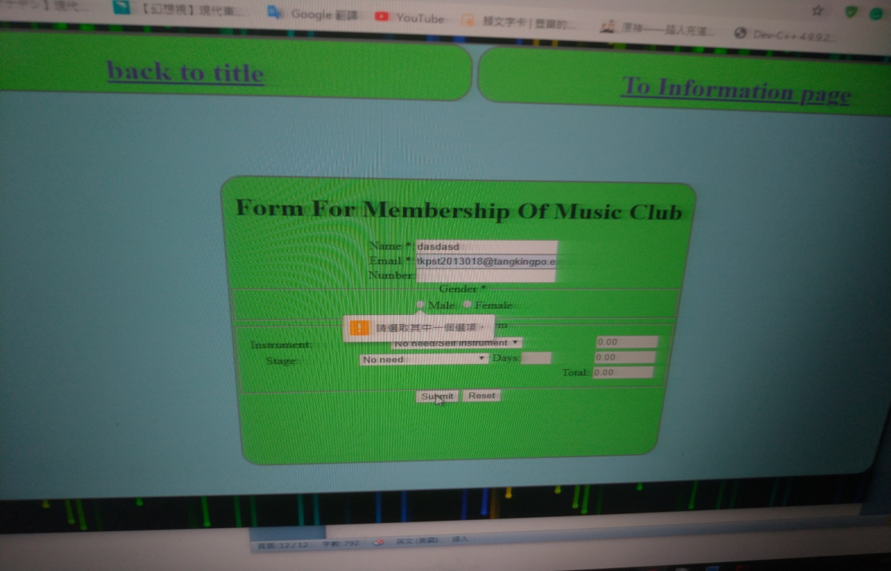

(input phone in wrong format)

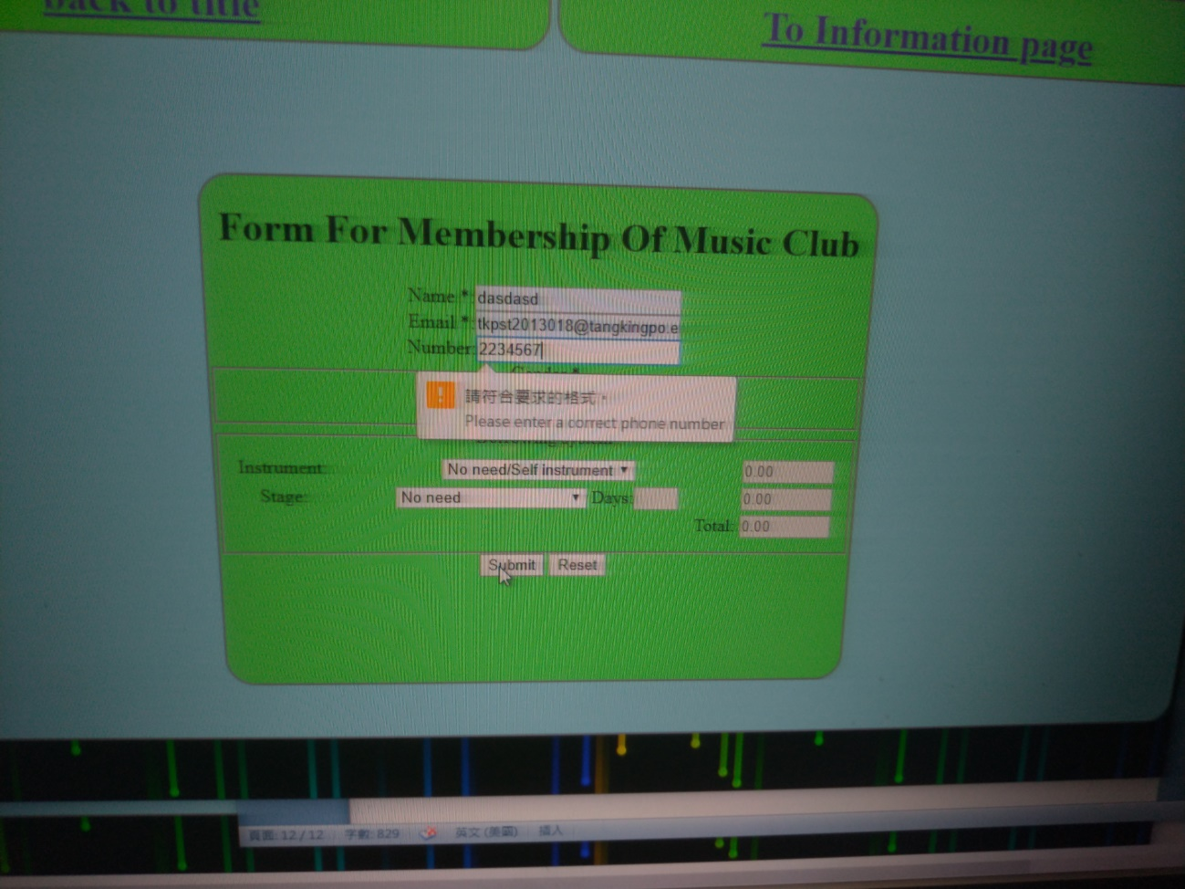

(Input successful)

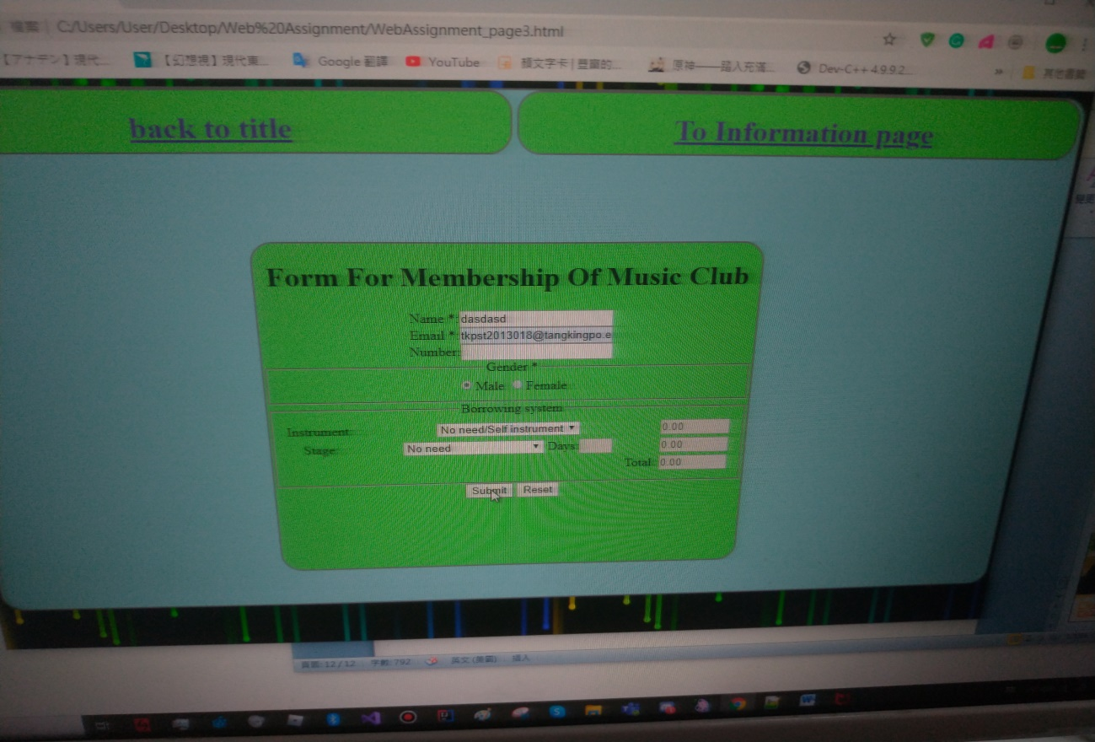

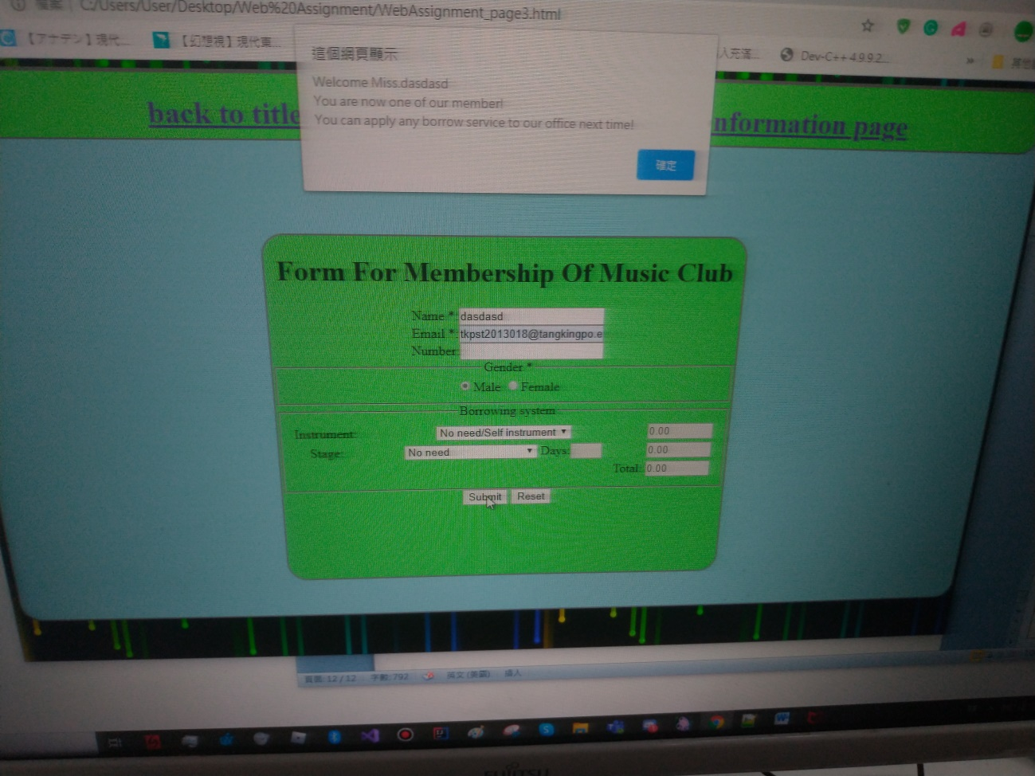

About the Borrowing system part.  
Firstly,I initialize of the 4 text box, days box, 3 price store box to make them disable  
by this part of javascript.  
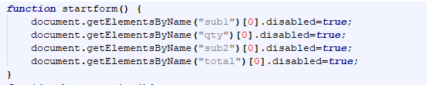

Second, I make the select of first price store box and the total box follow the value of the selection of instrument by this function.  
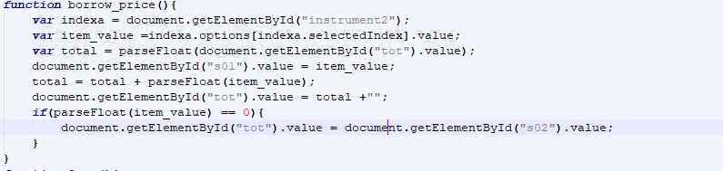

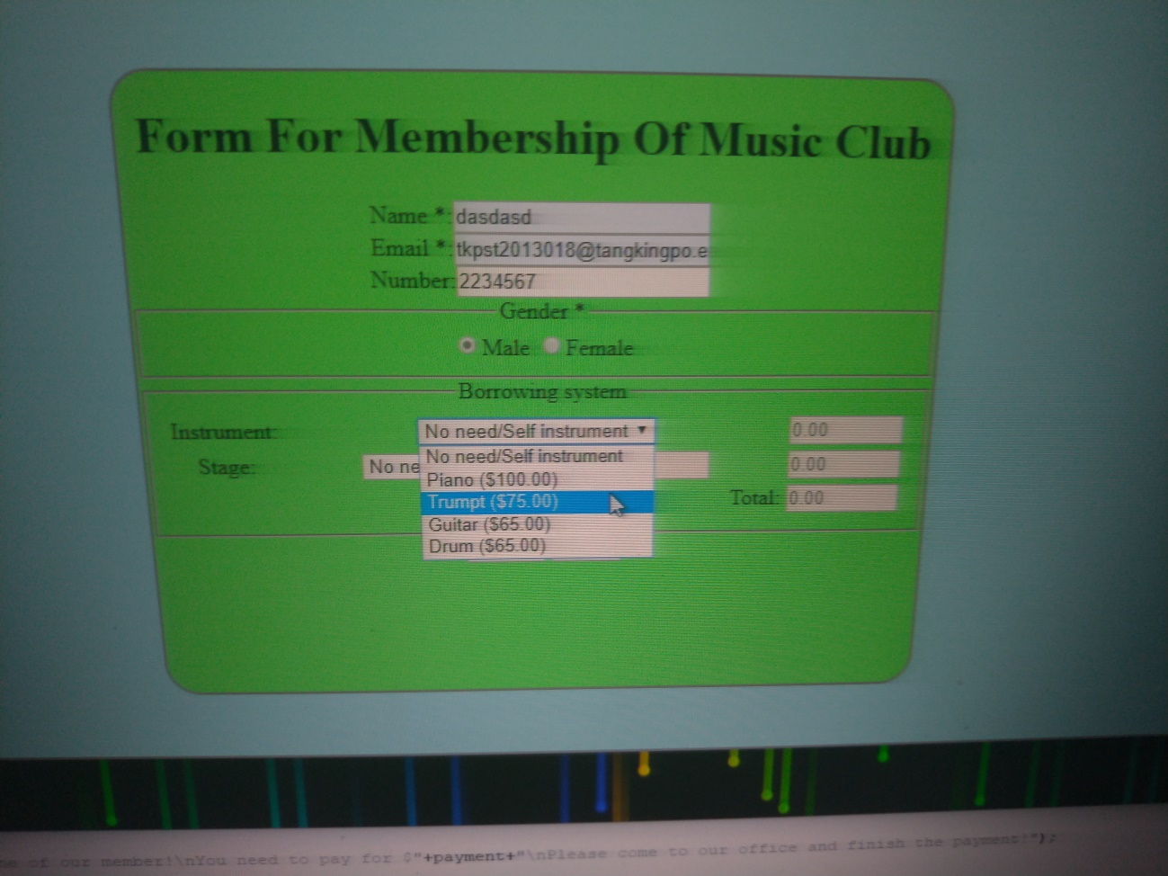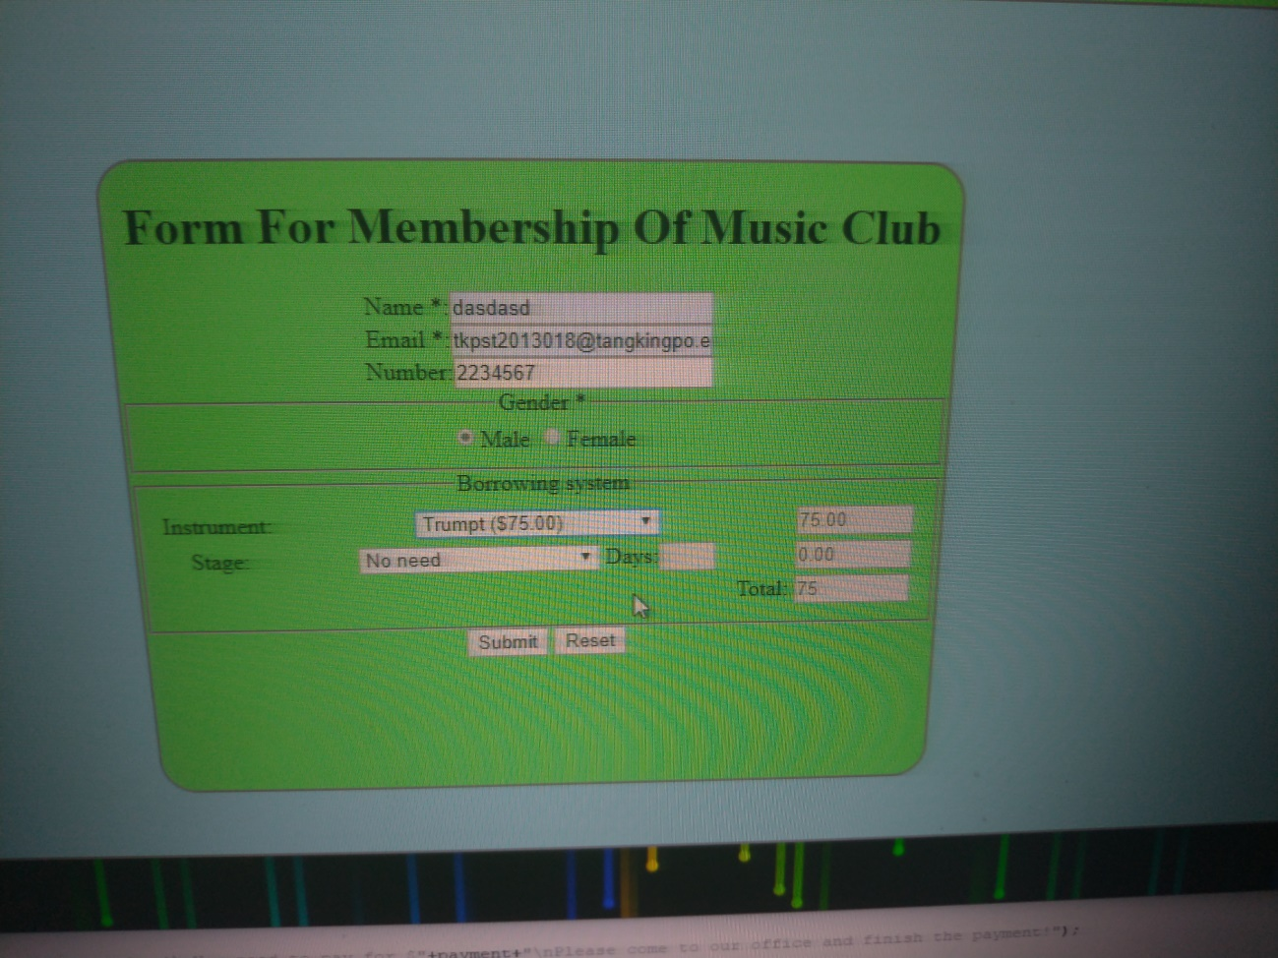  
The user can just submit the form like this, but they can also select the stage they want to borrow, in this scenario, the stage can be borrow for 7 day long as much. But the box store the value of day is disabled in the beginning. After the user choose on one of the select of stage box, the Days input box will be enabled.  
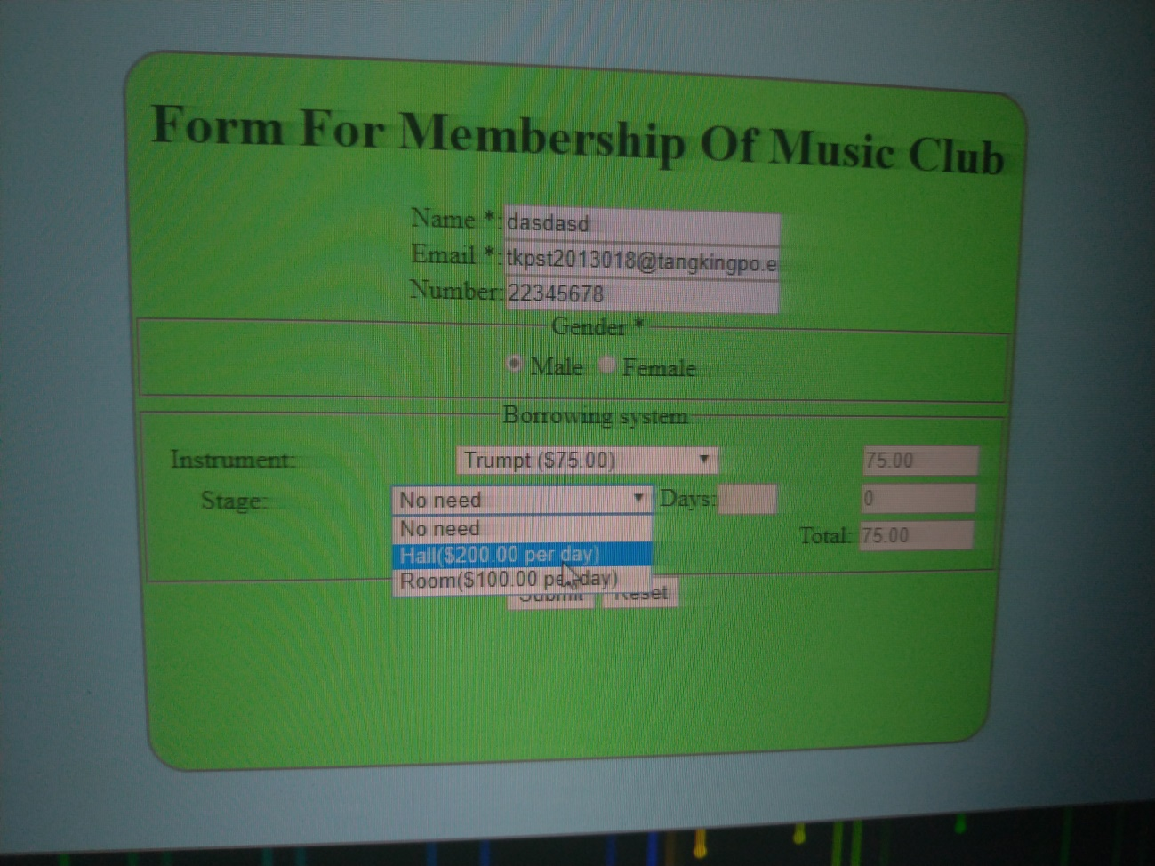

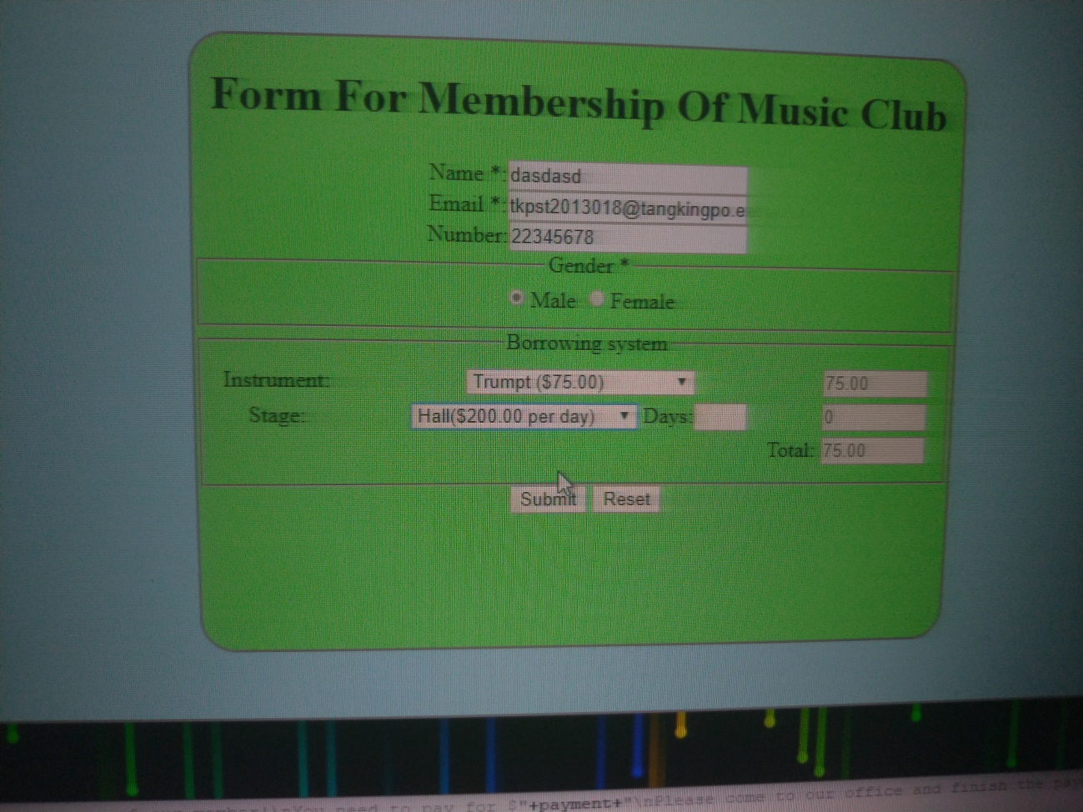

After the input box enabled, user can input the days they want to borrow for.  
After the day amount was input, the amount will appear in the second price store box. And the amount of the first and the second one will add up in the total box.  
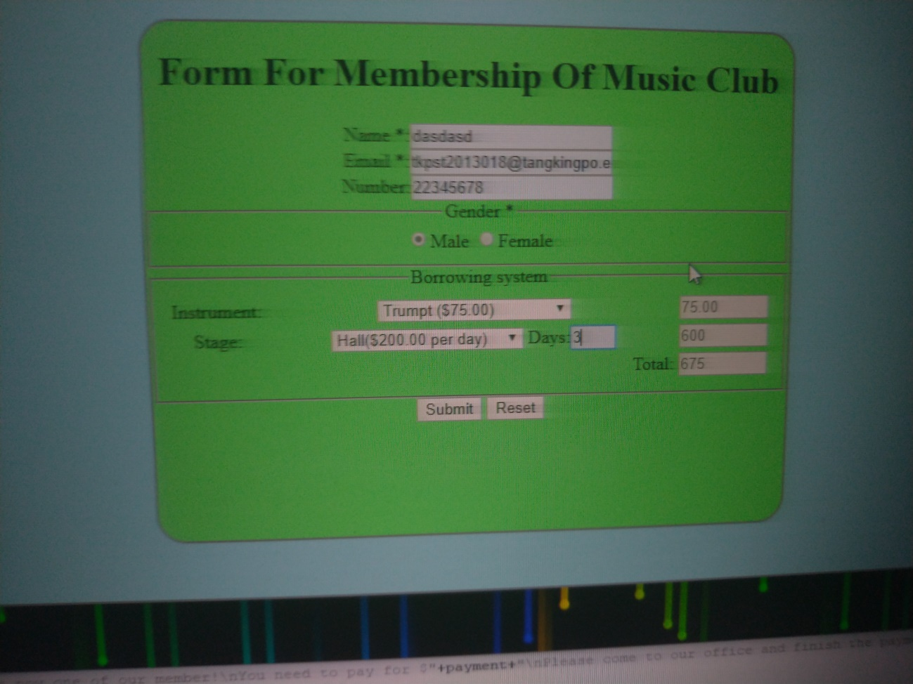

These step are finished by 2 function, one is in the select box(onChange="Open();") another is in the days input box (also onchange=”borrow_price2();”)

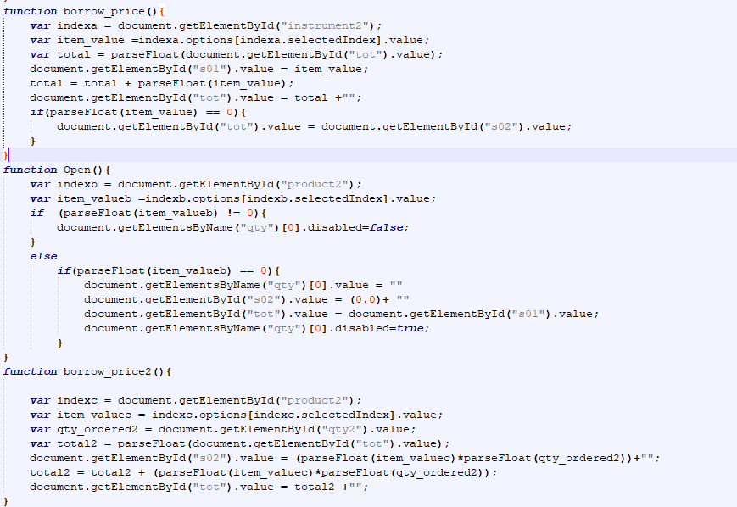

Finally, after the user click on the submit button, there will have a alert to tell him/her.  
There will totally 4 situation,

1. The user is a male and don’t use the borrow service.  
2.The user is a female and don’t use the situation.

3. The user is a male and used the borrow service.

4. The user is a female and used the borrow service.

(situation 3)

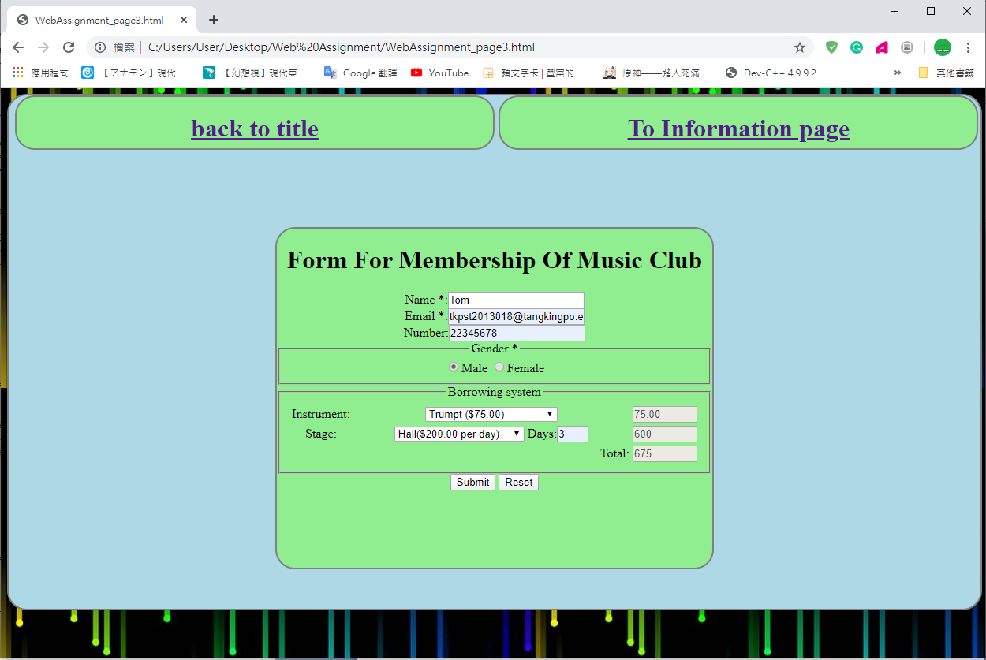

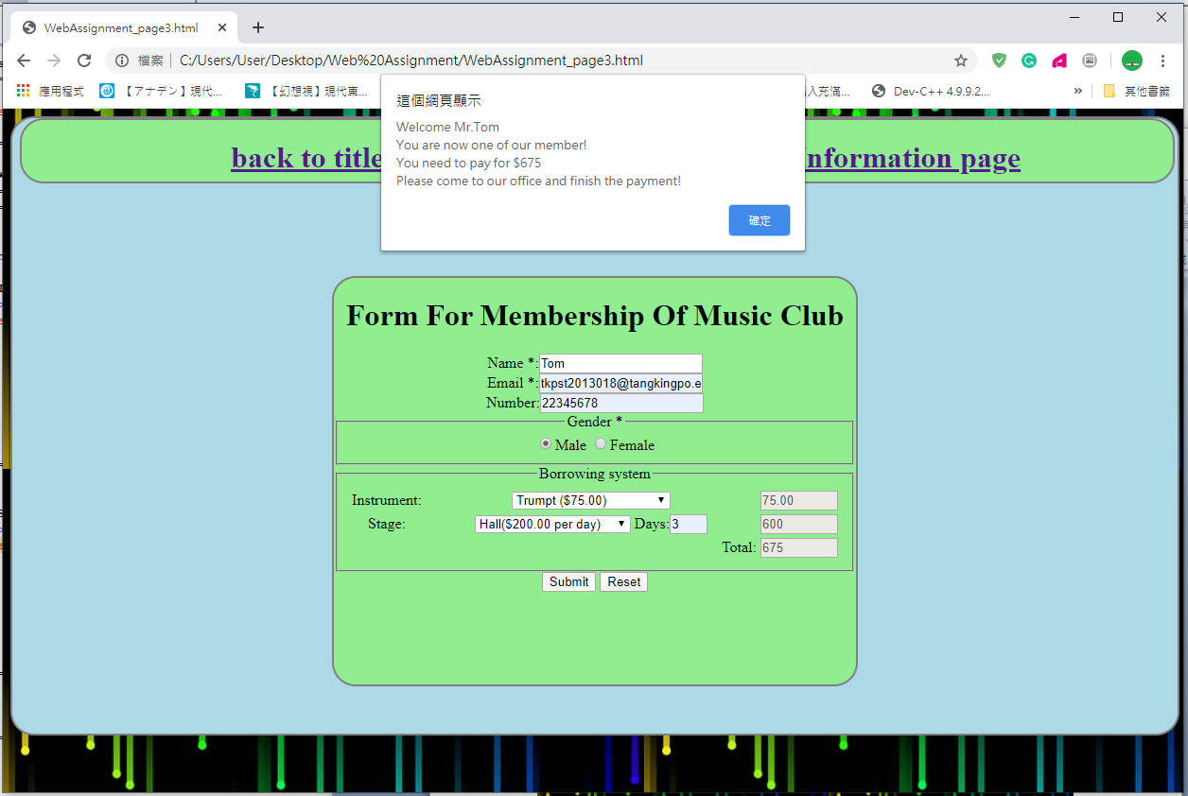

(situation 4)

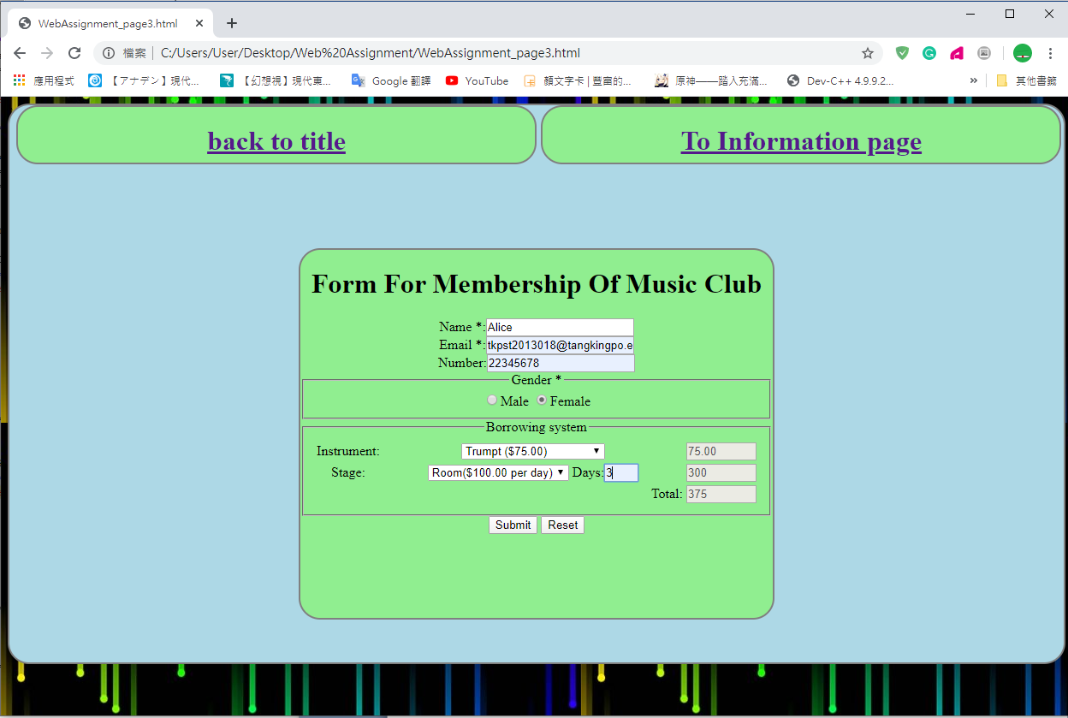

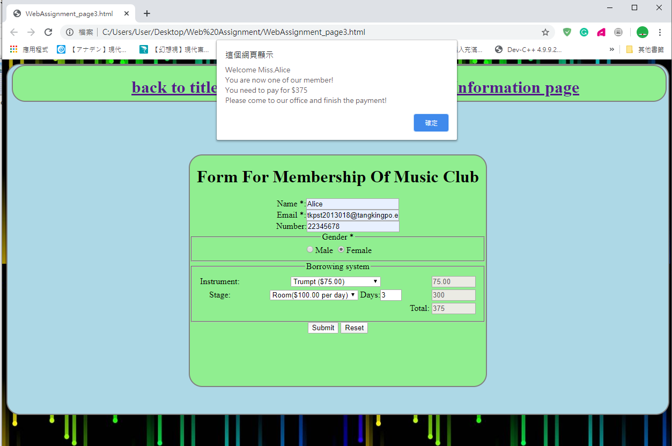

(situation 1)

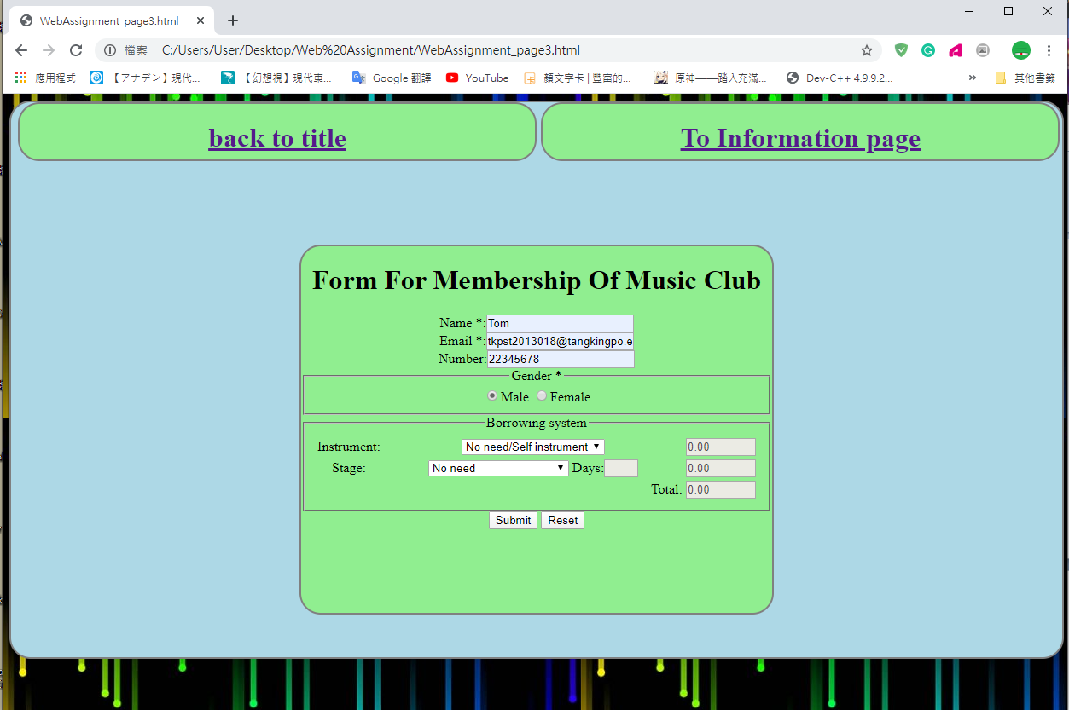

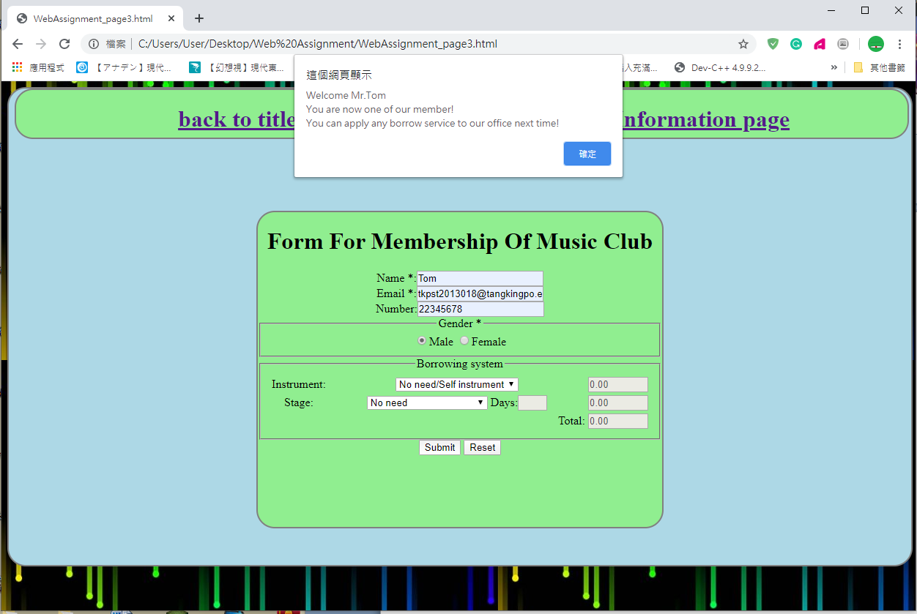

(situation 2)

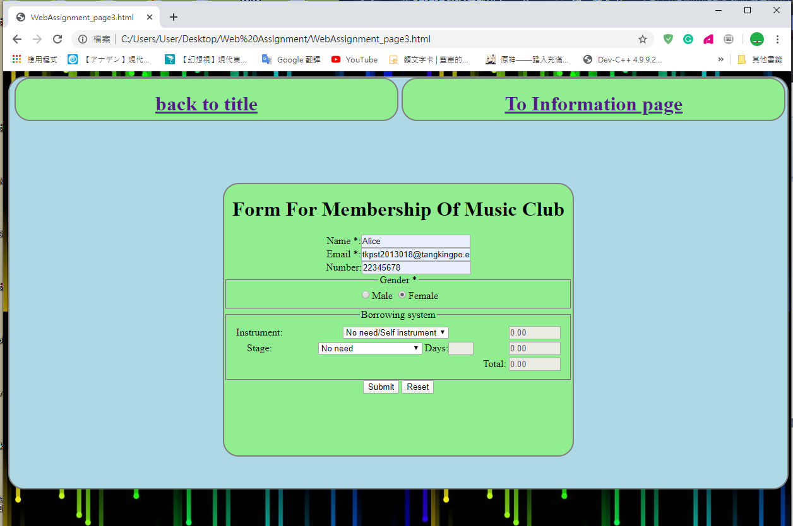

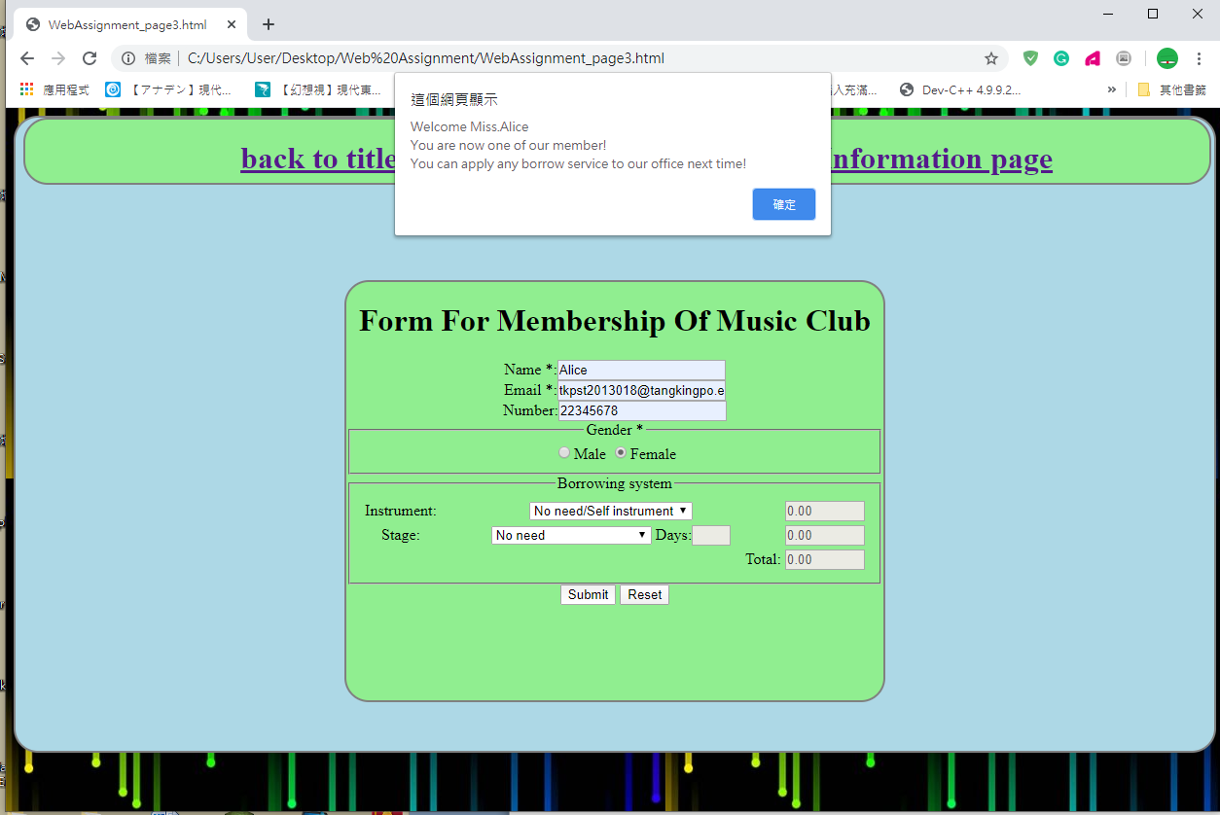

I do this checking by a function on the form(onsubmit="welcome()")

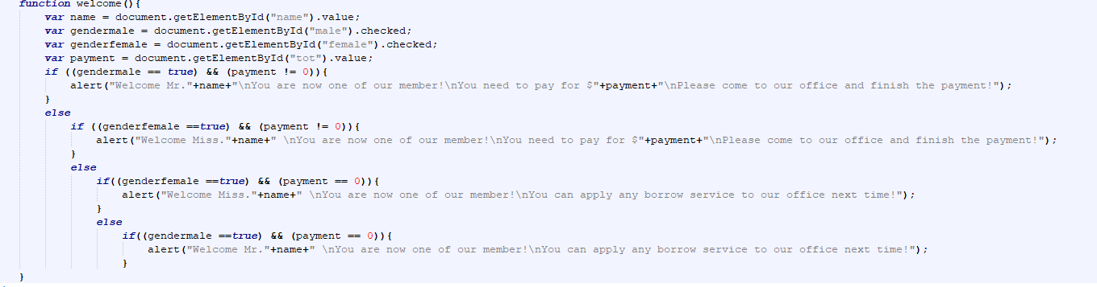

Moreover, if the user try to borrow a day length more than 7 day, the page will also stop the user from submit and tell him/her we only support for 7 day.

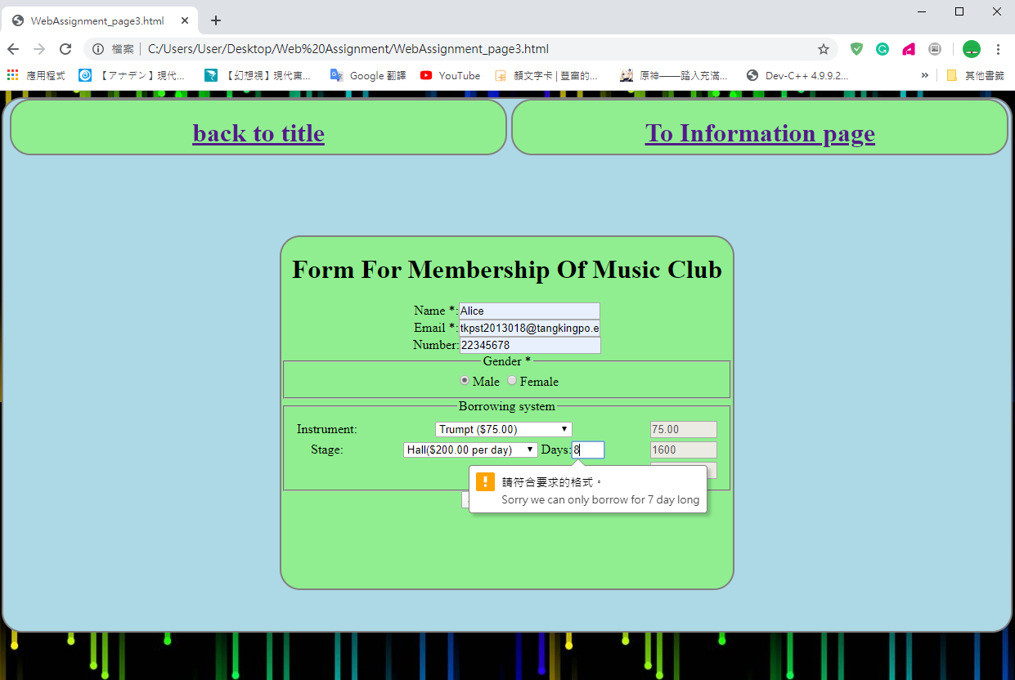

These are all features from my 3 pages web design. Thank you.